DevOps: - UI Testing Assignment - 1

Name – Hitt Jain
Roll no. 2302901520090
Branch – AI(B)
Github repo link - HittJain/UI-Testing-Assignment: Devops - ASSIGNMENT 1
VALID TEST CASES : GMAIL
- Gmail Login Page Load
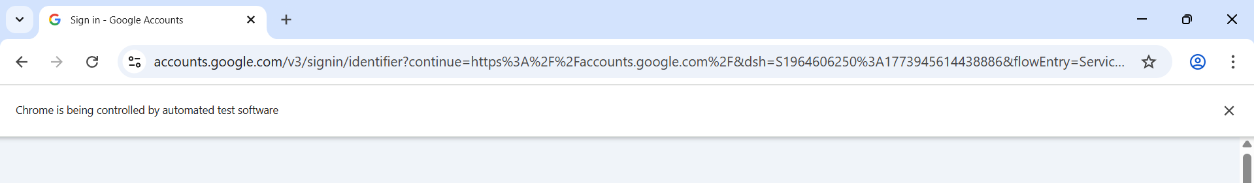
- Invalid Email Error
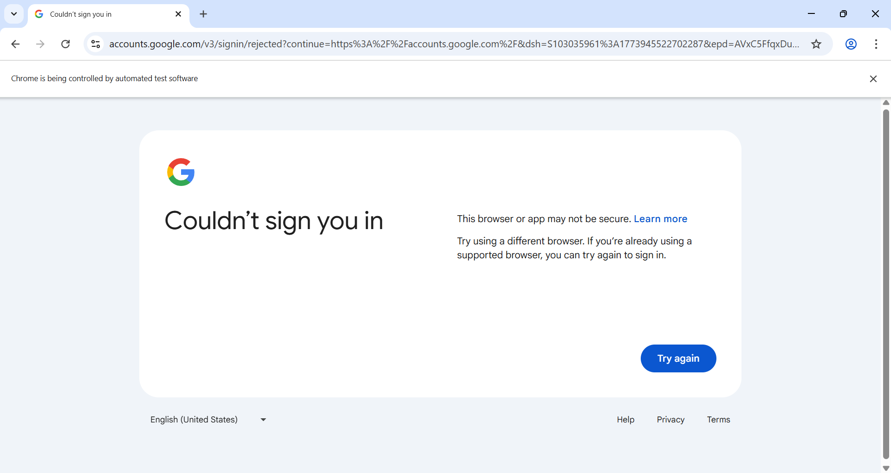
- Empty Field Validation
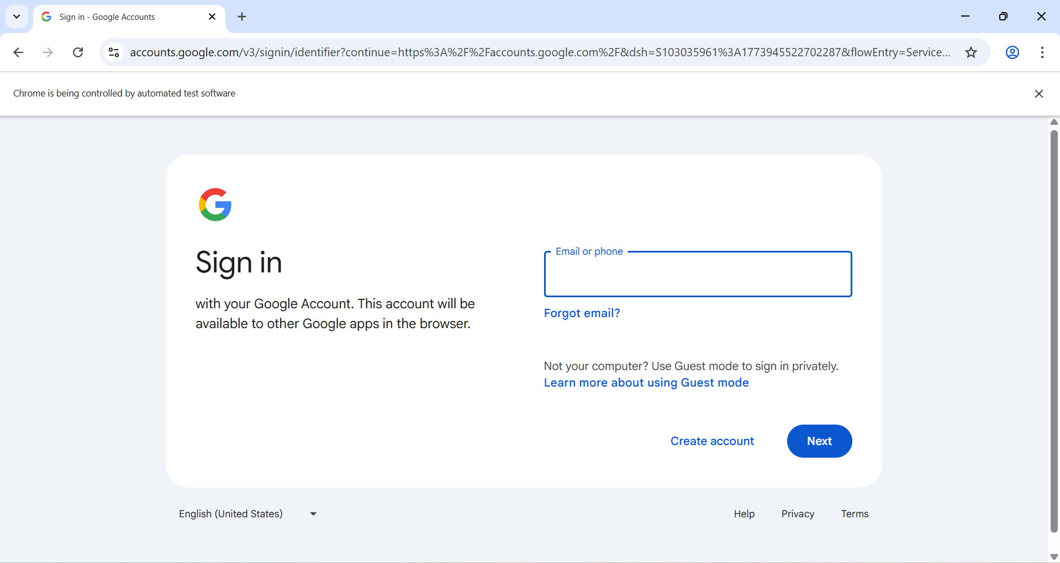
- "Forgot Email" Navigation
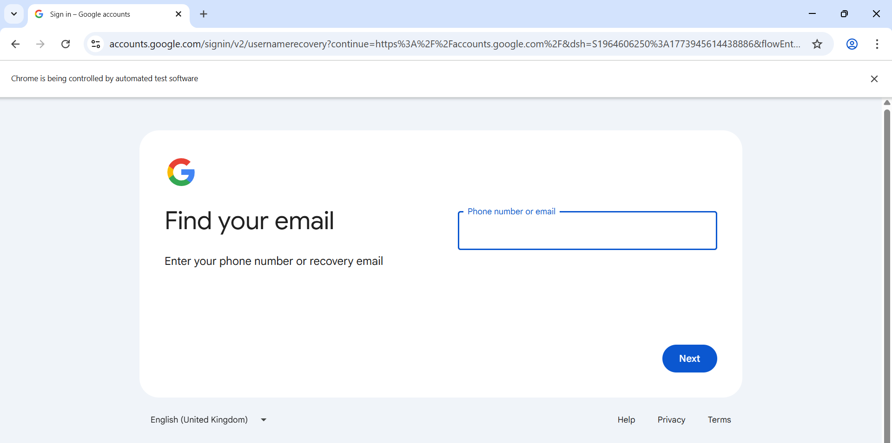
- "Create Account" Navigation
